NOTICE OF MEETING
WATERWOOD MUNICIPAL UTILITY DISTRICT NO. 1
OF SAN JACINTO COUNTY, TEXAS

TO: THE BOARD OF DIRECTORS OF WATERWOOD MUNICIPAL UTILITY DISTRICT NO. 1 OF SAN JACINTO, TEXAS, AND TO ALL OTHER INTERESTED PERSONS:
Notice is hereby given that the Board of Directors of the Waterwood Municipal Utility District No. 1 of San Jacinto County, Texas, will meet in regular session, open to the public, at 3:00 P.M. on FRIDAY, August 15, 2025, at 24518 PECAN TREE LANE, HUNTSVILLE, TEXAS, (in the Waterwood Improvement Association building, Waterwood Parkway at Pecan Tree Lane).

At the meeting the following items will be considered and acted on:
- Call to order and welcome guests;

- Consent Agenda:
  - Minutes of Previous Meetings:
    - Approve minutes of July 18, 2025, meeting;
  - Bookkeeping & Financial Matters:
    - Approve financial report;
    - Authorize payment of bills;
  - Tax Collection Matters:
    - Approve tax receipt and disbursement report;
- Director’s matters:
  - Review and adopt the budget for 2026
  - Review and adopt Rate Order
  - Establish September 19, 2025 as public hearing for approval of Budget and Rate Order
  - Approval of meter installation at 7465 FM 980 N (new build)
- Project Matters:
  - Receive update on Bond;
  - Receive update on FEMA request;
- Operations & Maintenance Matters:
  - Receive operations and maintenance report [Precision Utility];
  - Approve Work Orders;
  - Terminate utility service to customers with delinquent accounts;
  - Authorize other appropriate action;
- Consider other matters that may come before the Board.
- Receive comments or questions from the public;
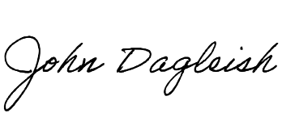
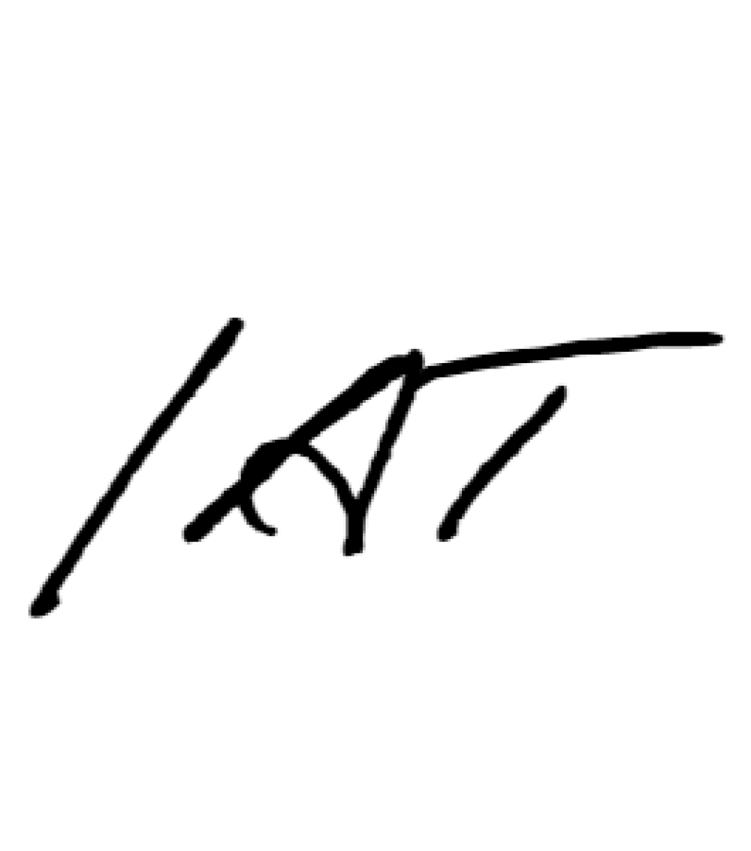
- Consider adjournment.

John Dagleish, Secretary
WMUD No. 1 Payment Address:
2 Waterwood Parkway
Huntsville, Texas 77320
Phone: (936) 891-7182

